Software Requirements Specification

(SRS)

Project Title: Breadfast

Course: Software Engineering

Deliverable: SRS Document (2nd Deliverable)
Team: Mark Fady-241000767, Karim Abotabl-241001720, Amr Alashwat-241001763, BahaaEldin Bakry-241000433, Ahmed Alaa-241001493

Date:

Table of Contents
[Auto-generated Table of Contents will appear here]

List of Figures
Figure 1. System Architecture – Logical Architecture Model Figure 2. Use-Cases Diagram
Figure 3. Activity Diagram for UC-01 Figure 4. Activity Diagram for UC-02 Figure 5. Activity Diagram for UC-03 Figure 6. Activity Diagram for UC-04 Figure 7. Activity Diagram for UC-05 Figure 8. Activity Diagram for UC-06 Figure 9. Activity Diagram for UC-07 Figure 10. Activity Diagram for UC-08 Figure 11. Activity Diagram for UC-09 Figure 12. Activity Diagram for UC-10 Figure 13. Activity Diagram for UC-11

List of Tables
Table 1. Use Case UC-01 Description Table 2. Use Case UC-02 Description Table 3. Use Case UC-03 Description Table 4. Use Case UC-04 Description Table 5. Use Case UC-05 Description Table 6. Use Case UC-06 Description Table 7. Use Case UC-07 Description Table 8. Use Case UC-08 Description Table 9. Use Case UC-09 Description Table 10. Use Case UC-10 Description Table 11. Use Case UC-11 Description

Introduction

Purpose
The purpose of this Software Requirements Specifications (SRS) is to identify the functional and non-functional requirements of the Breadfast application. It highlights the system’s main features, expected system behavior, and the constraints to provide a clear reference for the system’s development. This document is made for the customers, developers, testers, and other stakeholders that are involved in the project. It will provide a common understanding of the system’s requirements and provide a foundation for the implementation and testing phases.

Business Context
Breadfast is a food and grocery online delivery platform who main goal is to make shopping easier for customers of every age group, instead of going down shopping you can shop through the comfort of your home, by allowing customers to search available products, manage their own shopping carts, place orders, and track their orders, all through a single mobile application. The system supports these goals by cleanly organizing products, customers, and order information and providing a straightforward ordering process. The strategic alignment is in improving customer shopping experience for senior citizens, and efficient order management. The project is modeled as an android and IOS application.

Blah blah blah gibberish

General Description

Product Functions
The Breadfast application will provide the following main functions:
- Browse and Search Products: Allows customers to check on available products, search for certain items, and check product prices and nutritional facts.
- Manage Shopping Cart: Allow customers to add and remove products from their shopping carts and select the quantity of each item they are ordering.
- Place Orders: Allow customers to order the items they placed in their shopping cart.
- Payment: Allow customers to choose the type of payment they would like whether cash or visa or pay in the app.
- Manage Products: Allow administrators to add, update, or remove product information.
- Manage Orders and Delivery Information: Allow administrators to manage orders and update the related delivery information.

Similar System Information
The application will not work completely on its own, as it will need a backend connection and a database to manage information about the customer, items and order history. For online payment, the system will have to connect with an external payment bridge to process transactions safely, the application will also need good security to avoid any data being corrupted. The application will depend entirely on delivery and order fulfillment, to ensure orders are handled safely and the customer receives the correct order. These connections are a necessity for the application to provide the main functions effectively.

User Characteristics
The Breadfast application has two main types of users:
Customers: Customers who want to purchase food and groceries online. The age group and experience using phone is varied, so the interface is simple and easy to understand where every option is highlighted and what it does. They will be able to browse products, manage their carts, place orders, and track orders without any technical and non-technical problems.
Administrators: The administrator is responsible for managing product information, customer records, orders, and delivery information. They should have basic technical knowledge and would be able to use the system and update information and manage records with no issues.

Gibberish and more gibberish

User Problem Statement
The application handles two main problems that are related to online food and grocery ordering.
The first problem is in the efficiency . Customers need a clear process that allows them to browse products, select items, manage their carts, and place orders without unnecessary steps or loss of information.
The second problem is inconsistent management of customer, product, cart, and order data. Incorrect or duplicated records may cause problems during order processing. The system should maintain accurate relationships between customers, their orders, and the products and quantities they select.

User Objectives
List objectives users expect from the system and how success will be measured. It may include a ”wish list” of desirable characteristics, along with more feasible solutions that are in line with the business objectives.

General Constraints
List technological, legal, budgetary, or operational constraints.

System Features
This section details the functional scope of the system using diagrams and descriptions.

3.1. Functional Requirements
Each requirement should be presented using the following table format.
This section lists the functional requirements in ranked order. Functional require- ments describes the possible effects of a software system, in other words, what the system must accomplish. Other kinds of requirements (such as interface re- quirements, performance requirements, or reliability requirements) describe how the system accomplishes its functional requirements see table 1. Each functional re- quirement should be specified in a format similar to the following:
1-
Place Orders | Place an order.
Description | A full description of the requirement.
Critically | Describes how essential this requirement is to the overall system.
Technical issues | Describes any design or implementation issues involved in satisfying this requirement.
Cost and | Describes the relative or absolute costs associated with this issue.

schedule
Risks | Describes the circumstances under which this requirement might not able to be satisfied, and what actions can be taken to reduce the probability of this occurrence.
Dependencies with other requirements | Describes interactions with other requirements.
Pre-Condition | The state of the system before the running of the function
Post-Condition | The state of the system after the run of the function
Input | ---
output

2-
Add Products to Cart | Add a product to the shopping cart.
Description | A full description of the requirement.
Critically | Describes how essential this requirement is to the overall system.
Technical issues | Describes any design or implementation issues involved in satisfying this requirement.
Cost and | Describes the relative or absolute costs associated with this issue.

schedule
Risks | Describes the circumstances under which this requirement might not able to be satisfied, and what actions can be taken to reduce the probability of this occurrence.
Dependencies with other requirements | Describes interactions with other requirements.
Pre-Condition | The state of the system before the running of the function
Post-Condition | The state of the system after the run of the function
Input | ---
output

3-
Registration | Register a new customer account.
Description | A full description of the requirement.
Critically | Describes how essential this requirement is to the overall system.
Technical issues | Describes any design or implementation issues involved in satisfying this requirement.
Cost and | Describes the relative or absolute costs associated with this issue.

schedule
Risks | Describes the circumstances under which this requirement might not able to be satisfied, and what actions can be taken to reduce the probability of this occurrence.
Dependencies with other requirements | Describes interactions with other requirements.
Pre-Condition | The state of the system before the running of the function
Post-Condition | The state of the system after the run of the function
Input | ---
output
4-
Login | Log in to an existing customer account.
Description | A full description of the requirement.
Critically | Describes how essential this requirement is to the overall system.
Technical issues | Describes any design or implementation issues involved in satisfying this requirement.
Cost and | Describes the relative or absolute costs associated with this issue.

schedule
Risks | Describes the circumstances under which this requirement might not able to be satisfied, and what actions can be taken to reduce the probability of this occurrence.
Dependencies with other requirements | Describes interactions with other requirements.
Pre-Condition | The state of the system before the running of the function
Post-Condition | The state of the system after the run of the function
Input | ---
output

5-
Modify item quantity | Modify the quantity of a product in the shopping cart.
Description | The system shall allow the customer to change the quantity of a certain item whether to decrease or increase rather than making multiple orders of one item. The system shall update the total amount that will be paid based on the number of times the customer wants the item. The quantity will be a positive whole number
Critically | High. This function allows the customer to change their purchases according to the amount they want of that item ,this also has an effect on the payment amount.
Technical issues | The system must check the quantity, update the cart correctly, recalculate prices, and save changes to prevent data from being lost. It should also prevent customers from exceeding the available stock, the customer cannot decrement less than one as then the item will be removed from the cart.
Cost and | No direct cost is expected if existing development tools and database software are used.

schedule
Risks | Incorrect quantity ordered, wrong price calculations, or failed database updates could cause inconsistencies in the cart. These risks can be reduced through input validation, automatic price recalculation, database consistency checks, and functional testing.
Dependencies with other requirements | Depends on Add Products to Cart, since a product must already be in the cart. It also interacts with Remove Products from Cart and Place Orders.
Pre-Condition | The customer is logged in and has at least one item in their shopping cart.
Post-Condition | The selected item's quantity is updated, the subtotal and total cart price are recalculated, and the updated cart information is saved.
Input | The selected item and its new quantity, entered directly or adjusted using increase/decrease controls.
output | The updated shopping cart displaying the new quantity, recalculated subtotal, and total price. An error message is displayed if the entered quantity is invalid.

6-
Remove Products from Cart | Remove a product from the shopping cart.
Description | A full description of the requirement.
Critically | Describes how essential this requirement is to the overall system.
Technical issues | Describes any design or implementation issues involved in satisfying this requirement.
Cost and | Describes the relative or absolute costs associated with this issue.

schedule
Risks | Describes the circumstances under which this requirement might not able to be satisfied, and what actions can be taken to reduce the probability of this occurrence.
Dependencies with other requirements | Describes interactions with other requirements.
Pre-Condition | The state of the system before the running of the function
Post-Condition | The state of the system after the run of the function
Input | ---
output

7-
Admin Dashboard | Access the admin dashboard to manage system information.
Description | A full description of the requirement.
Critically | Describes how essential this requirement is to the overall system.
Technical issues | Describes any design or implementation issues involved in satisfying this requirement.
Cost and | Describes the relative or absolute costs associated with this issue.

schedule
Risks | Describes the circumstances under which this requirement might not able to be satisfied, and what actions can be taken to reduce the probability of this occurrence.
Dependencies with other requirements | Describes interactions with other requirements.
Pre-Condition | The state of the system before the running of the function
Post-Condition | The state of the system after the run of the function
Input | ---
output
3.2 User-Cases
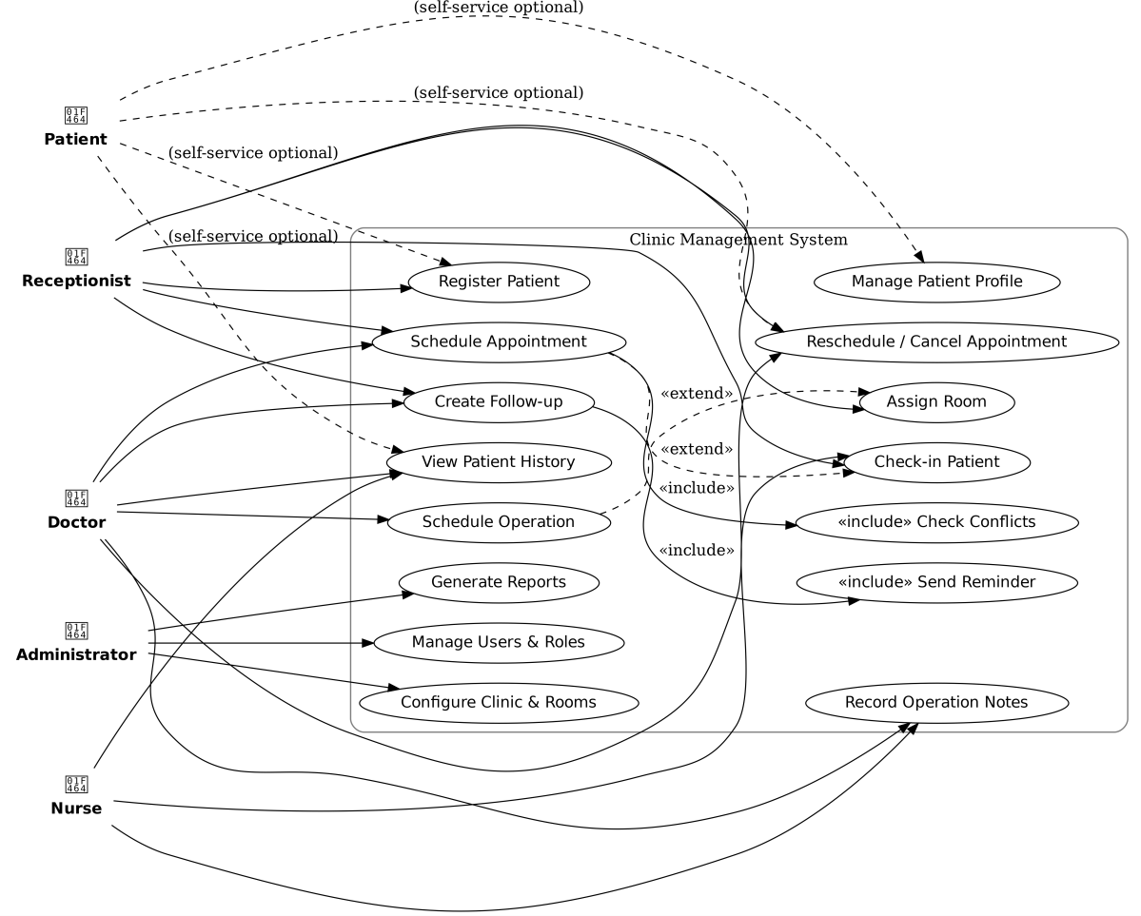

Figure 2: Use-Cases Diagram

Use Case: UC-01 – case 01
Primary Actor | Receptionist
Supporting Actors | Patient (info provider)
Stakeholders & Interests | Clinic: accurate records; Patient: quick registration; Compliance: data integrity
Trigger | Patient requests creation of a new record or first-time visit
Preconditions | Receptionist authenticated; Patient not  already registered (or duplicate handling available)
Minimal Guarantees | No data corruption; partial entries are either saved as draft or rolled back
Success Guarantees | New patient record created with unique ID;  audit entry recorded
Main Success Scenario | - Receptionist selects 'Register Patient'.  - System prompts for required demographics and contact details.  - Receptionist enters data and validates identifiers (e.g., phone/email).  - System checks for duplicates (name+DOB+phone).  - Receptionist confirms and saves record.  - System creates patient ID and logs audit entry.
Extensions / Alternative Flows | E1 – Duplicate suspected (Step 4): System shows possible matches; Receptionist links to existing record or confirms new.  E2 – Missing required field (Step 3): System highlights fields with inline validation; Receptionist completes and resubmits.
Special Requirements (Non-Functional) | - Data validation per field; inline error messages within 200 ms.  - p95 create latency ≤ 500 ms under 50  concurrent staff.  - All changes audited (who, when, what).
Frequency of Use & Business Rules | Frequency: High (daily)  - Phone or email is mandatory for contact.  - Full name + DOB are required to issue patient ID.
Traceability | FR-REG-01, FR-REG-02, NFR-SEC-01, NFR-PERF-01

- Specific Requirements
Each functional requirement is described in detail and is supported with activity diagrams for clarity.

Activity diagrams
Each functional requirement is described in detail and is supported with activity diagrams for clarity.

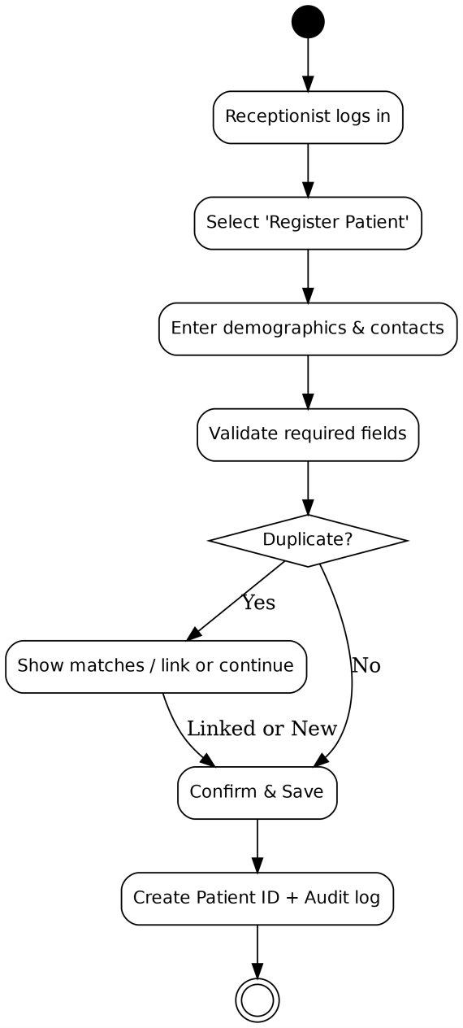
UC-01 Activity Diagram UC-01 Activity Diagram

Figure 3. Activity Diagram for UC-01

Interface Requirements

GUI
Include mockups or sketches of the main user interfaces.

CLI
If a command line interface is used, specify commands and arguments.

API
List exposed API endpoints, their parameters, return values, and examples.

Hardware Interfaces
List any hardware interfaces (e.g., printers, scanners).

Communications Interfaces
Specify communications protocols, network interfaces, and standards.

Software Interfaces
List any software components or external systems this system must interact with.

Performance Requirements
State performance objectives with measurable metrics (e.g., latency, throughput, capacity).

Design Constraints

Standards Compliance
Identify applicable standards.

Hardware Limitations
Specify hardware limitations.

Others
Add any other constraints.

Other Non-Functional Attributes
Describe Security, Reliability, Maintainability, Portability, Extensibility, Reusability, Resource Utilization, Serviceability.

The system shall meet performance, security, usability, availability, and compliance requirements. Each requirement is uniquely identified for traceability.
- NFR-PERF-01: Registration must complete in <500ms under normal load.
- NFR-PERF-02: Appointment scheduling conflict check must finish in <1s.
- NFR-SEC-01: All PHI data encrypted in transit and at rest.
- NFR-SEC-02: RBAC enforced with audit trails.
- NFR-AVAIL-01: System available 99.5% monthly uptime.

Operational Scenarios
Provide sample use cases and operational scenarios with actors, triggers, flows, and outcomes.

Appendices

Definitions, Acronyms, Abbreviations
Define key terms, acronyms, and abbreviations.

Collected Material
Include survey results, interview notes, competitor screenshots, and other collected material.

References
List references in proper citation format.

